Name These Serra Mesa Businesses

Business #1 & 2
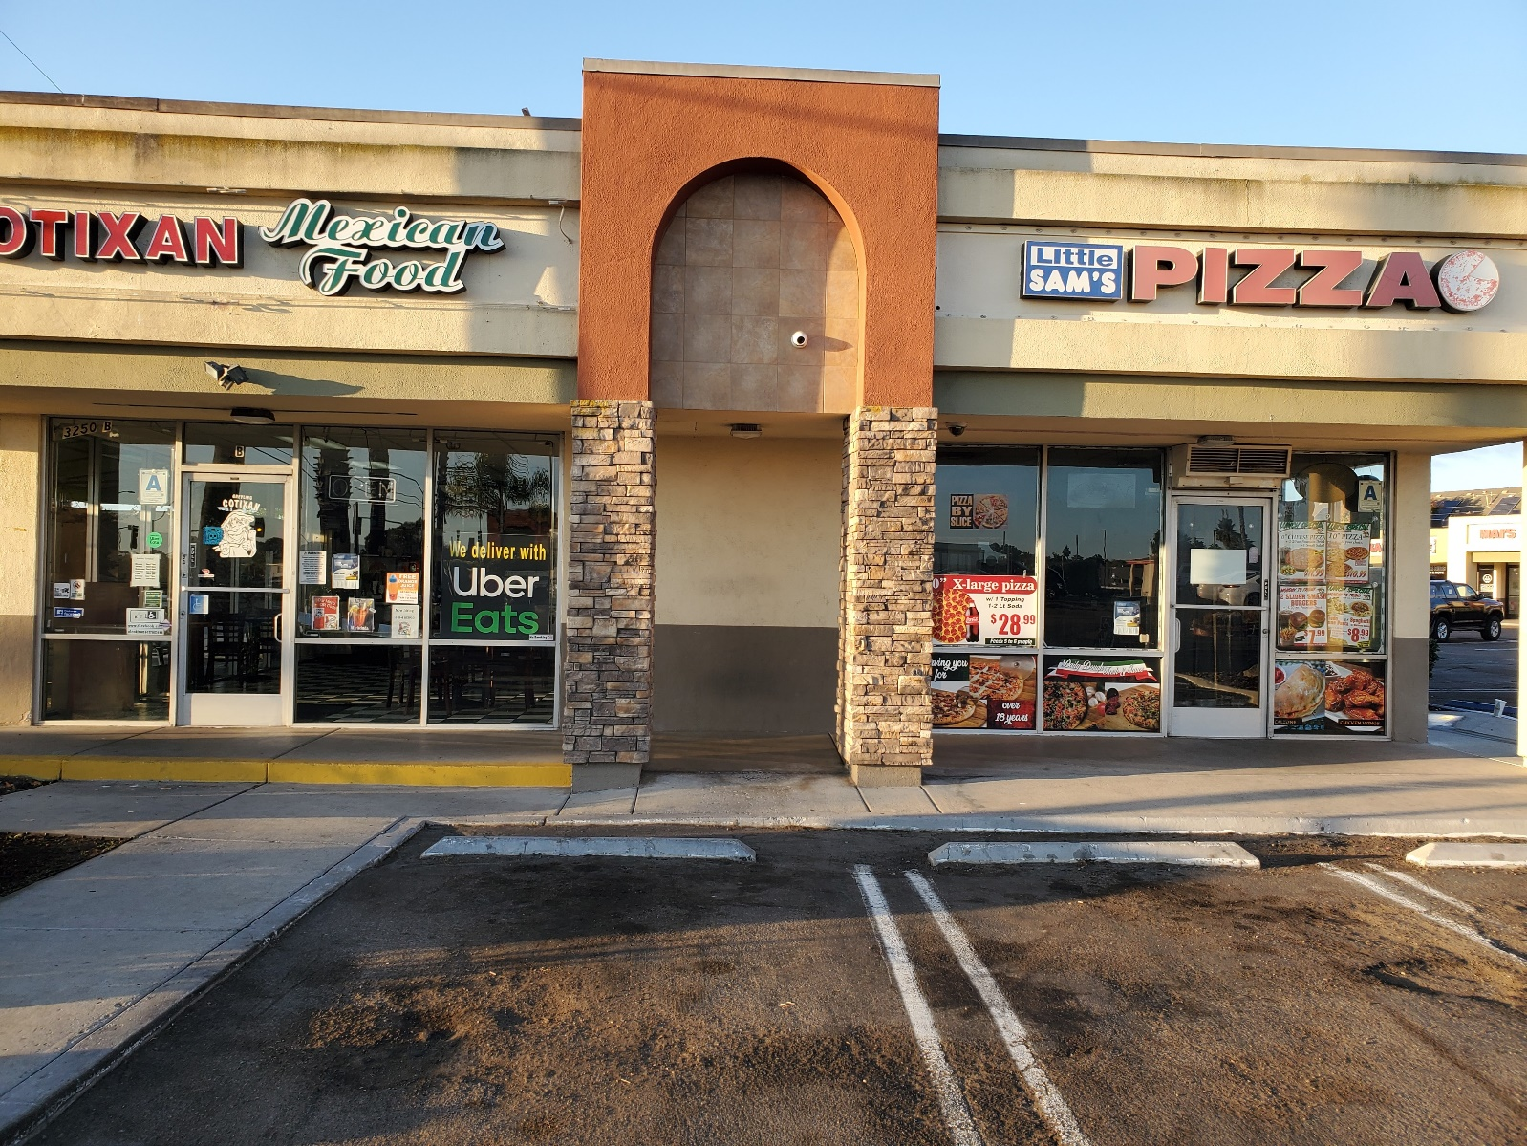

Business #3 & 4
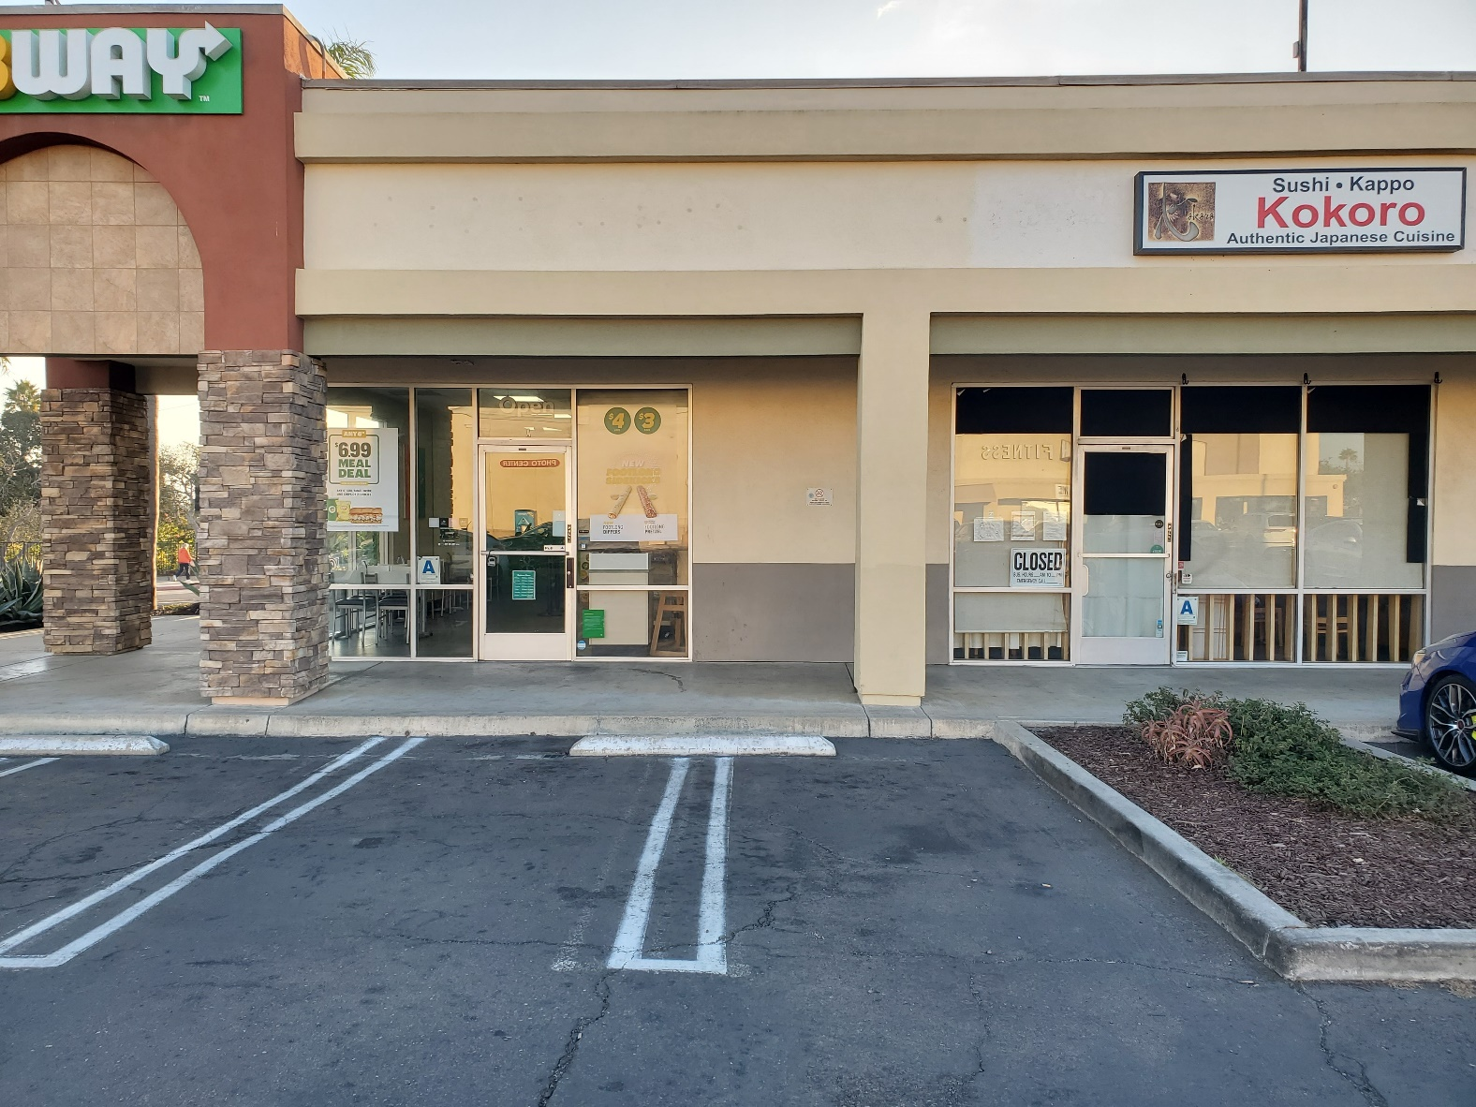

Business #5
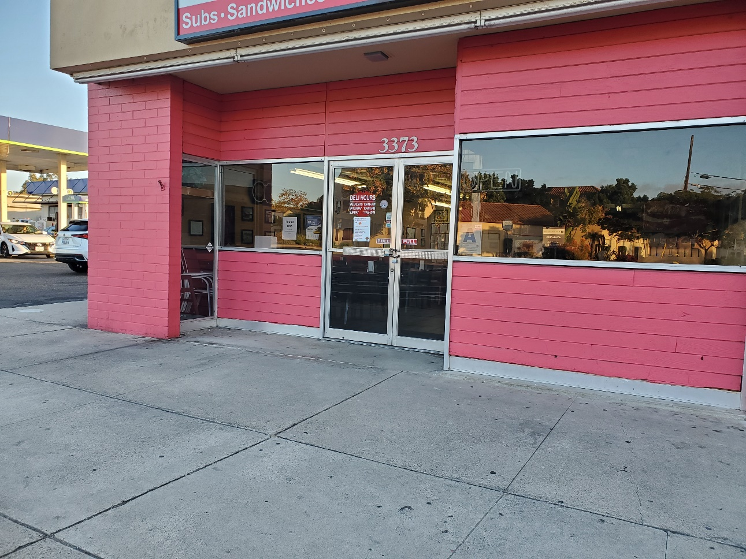
Business #6
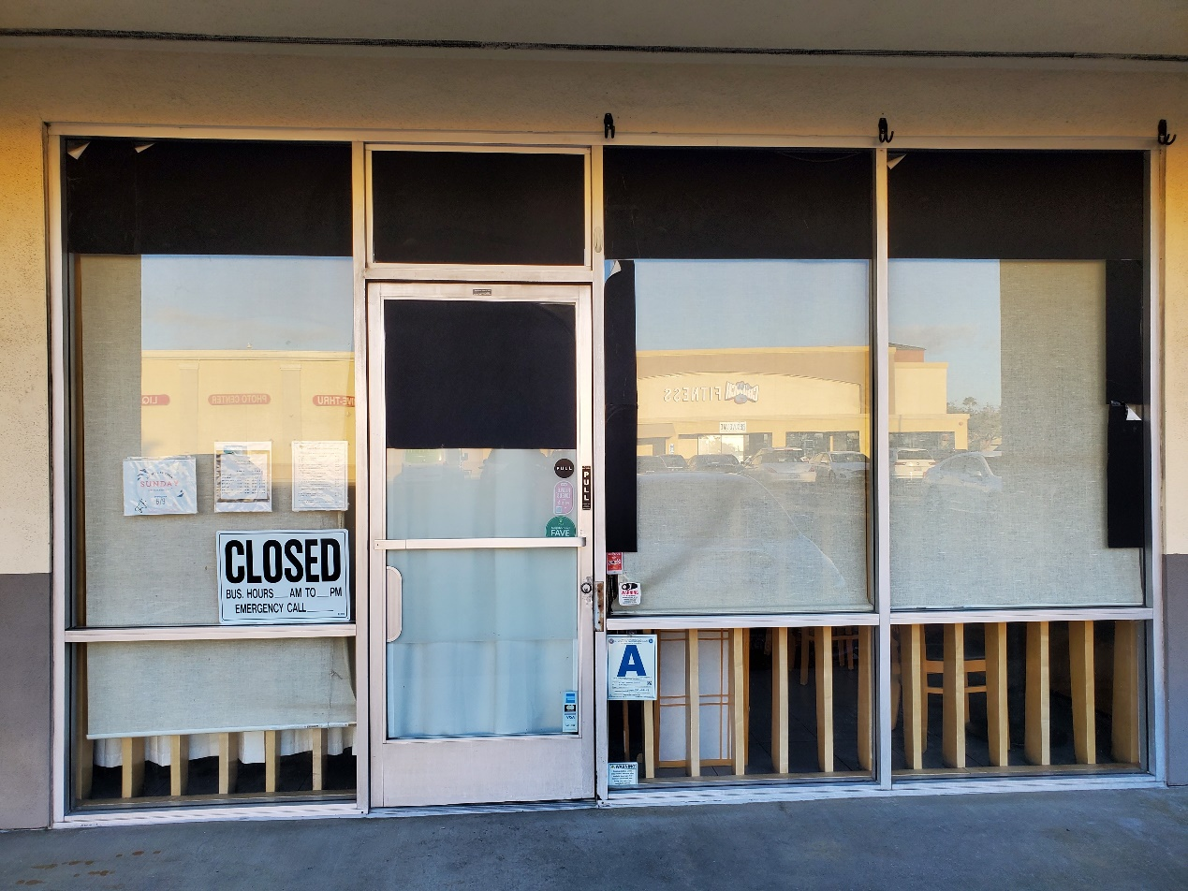

Brain Teaser Answers – Observer January/February 2025

Clue – Restaurant (Red)
Location #1 – Little Sams (Green)
Location #2 – Cotixan (Yellow)
Location #3 – Subway (Blue)
Location #4 – Kokoro (Orange)
Location #5 – Sandwich Company (Purple)
Location #6 – Thai Pepper Beige)
Maggies listed in previous edition.

R | L | I | T | E | S | M | S
E | S | T | T | L | A | R | T
C | O | A | A | N | A | N | E
T | I | X | U | R | S | P | P
O | K | R | A | W | U | I | E
K | O | O | Y | B | A | H | P
A | N | W | H | C | P | A | T
S | D | I | C | O | M | N | Y

